

CREATING A DOCKERFILE
DevOps Certification Training

support@intellipaat.com
+91-7022374614
US: 1-800-216-8930(Toll Free)

CREATING A DOCKERFILE
Step 1: First, create a folder docker, in the home directory
$ mkdir docker

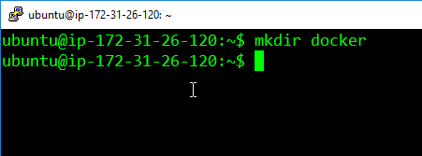
Step 2: Enter into this directory, and create a file called ‘Dockerfile’, with the same contents as the Sample Dockerfile. Add the following content in the Dockerfile.
$ cd docker
$ sudo nano Dockerfile

FROM ubuntu
RUN apt-get update
RUN apt-get -y install apache2
ADD . /var/www/html
ENTRYPOINT apachectl -D FOREGROUND
ENV name Devops Intellipaat

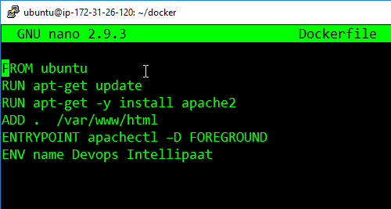

Step 3: Create one more file called, index.html with the following contents can verify the push on DockerHub.
$ sudo nano index.html
<html>
<title> Sample Website </title>
<body>
Hello World
</body>
</html>
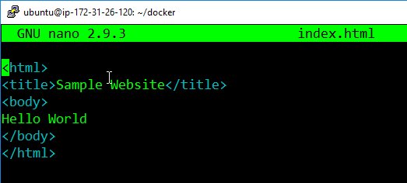

Step 4: Now pass the following command
$ docker build <directory-of-dockerfile> -t <name of container>

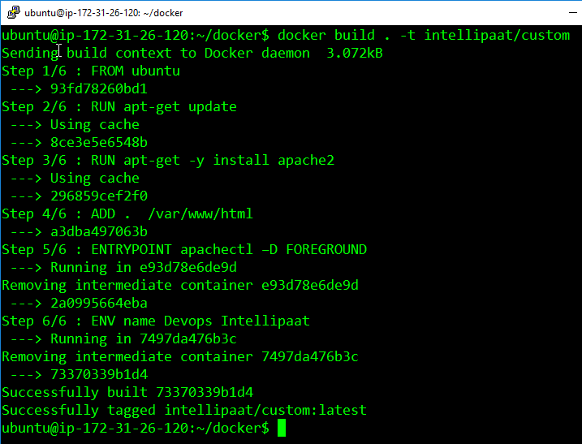
Step 5: Finally, run this built image, using the following command:
$ docker run –it –p 81:80 –d <name of container>
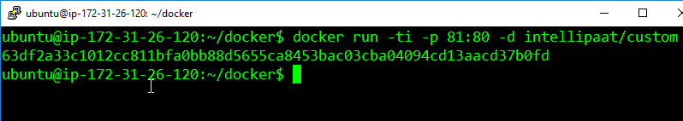

Step 6: Now navigate to the server IP address on port 81
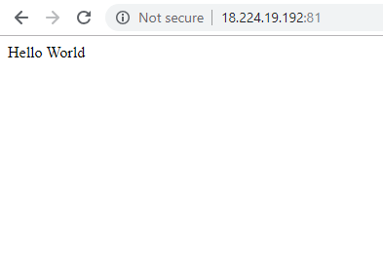
Step 7: Finally, login into the container, and check the variable $name, it will have the same value, as given in the Dockerfile.
